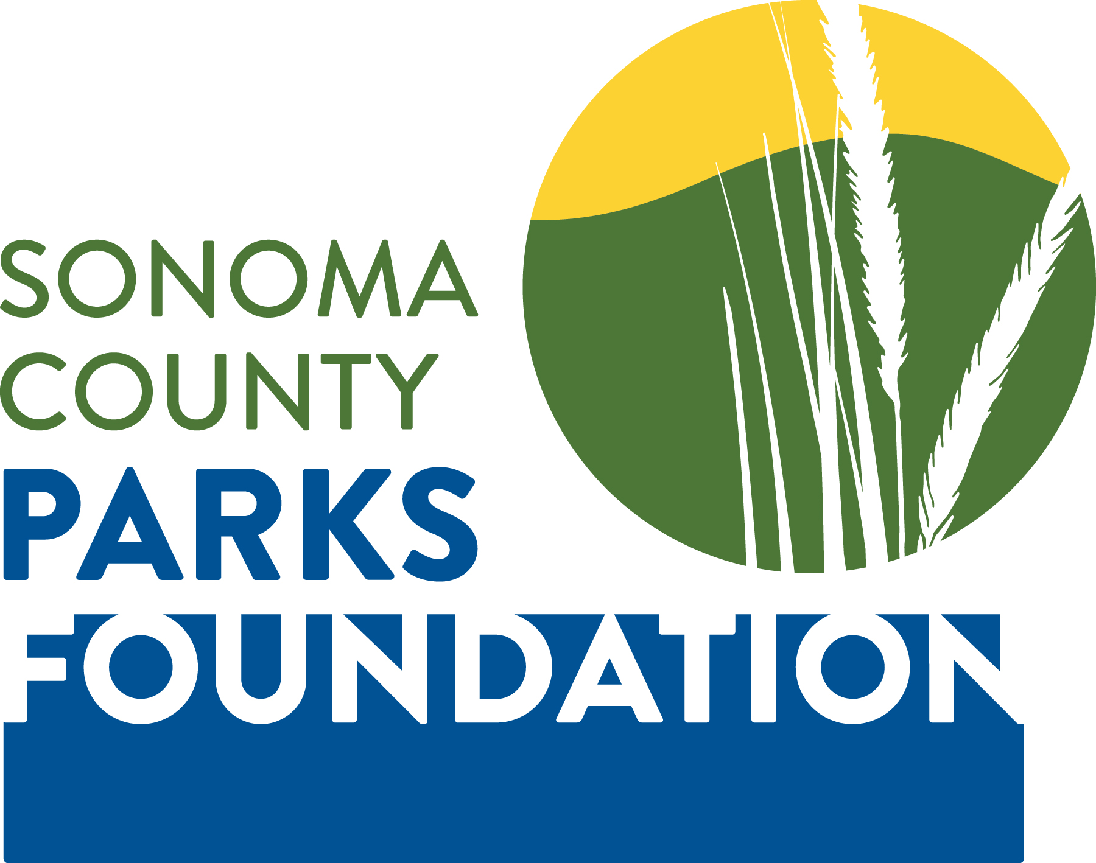
2019 Schedule

Meetings & Regional Parks

Special Events

Date | Time | Event
January 11, 2019  Note date change | 8:00 a.m. to 10:00 a.m. | Board Meeting
February 1, 2019 | 8:00 a.m. to 10:00 a.m. | Board Meeting
March 1, 2019 | 8:00 a.m. to 10:00 a.m. | Board Meeting
April 5, 2019 | 8:00 a.m. to 10:00 a.m. | Board Meeting
May 3, 2019 | 8:00 a.m. to 10:00 a.m. | Board Meeting
June 7, 2019 | 8:00 a.m. to 10:00 a.m. | Board Meeting
June 7, 2019 | 6:00 p.m. to 9:00 p.m. | Funky Fridays-opening night  (every Friday night through August 30, 2019)
July 12, 2019  Note date change | 8:00 a.m. to 10:00 a.m. | Board Meeting
August 2, 2019 | 8:00 a.m. to 10:00 a.m. | Board Meeting
August 30, 2019 | 5:30 p.m. to 9:00 p.m. | Funky Fridays-closing night
Multiple weekend dates  September 2019 TBA | 9:00 a.m. to 5:00 p.m. | Water Bark
September 6, 2019 | 8:00 a.m. to 10:00 a.m. | Board Meeting
October 4, 2019 | 8:00 a.m. to 10:00 a.m. | Board Meeting
October 2019 TBA | TBA | Tolay Fall Festival
November 1, 2019 | 8:00 a.m. to 10:00 a.m. | Board Meeting
December 4, 2019 | 10:30 a.m. to 2:00 p.m. | Best of the Best
December 5, 2019 | 8:00 a.m. to 10:00 a.m. | Board Meeting

Board Meetings are the First Friday of each month. Standard location is: Sonoma County Regional Parks 2300 County Center Drive, Conference Room A212, Santa Rosa, CA 95403

